**Writer’s Hub**

**Background and Product Context**

Writing is one of the most important and popular thing that people do all over the world. Starting from story and poem writing to blogs on daily affairs, it is the most popular act people choose to do for expressing their feelings, sharing their thoughts, raising their voices every day. And now a days, so many social platform has been created so that every thoughts can reach to the people whole around the world.

Staring from social medias to blog websites, people writes a lot daily about their daily and social lives. Sites like medium.com, wattpat.com, fictionpress.com etc. These sites are very popular for writers all over the world right now. Millions of people writes, posts everyday on those sites on various topics like daily affairs, fictions, science, math, technology, stories, poems, daily news, short stories, novels, business affairs, arts etc. These sites has make easier for the writers to reach people. So many writers do freelancing jobs also. So many writers got writing jobs also on various platforms.

Our website has so much similarity to those platforms. People can write anything they want, on any topic. The way it is better that, writers’ hub is going to be very much user friendly. It is very important that the site connects to the people and so that this has a better UI and UX Design and users can easily become use to this. There will be easy to use features. Writers can buy and sell their writings; for that, there will be a premium option.

Thus, our vision is to make things easier to connect to the people and reach them by their writings. It has a big opportunity to show their talents. And this site will ensure that.

**Interface Design**

**Homepage:**



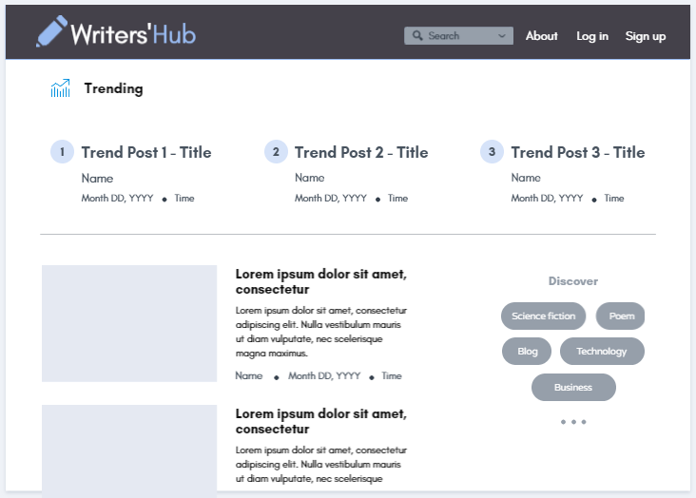

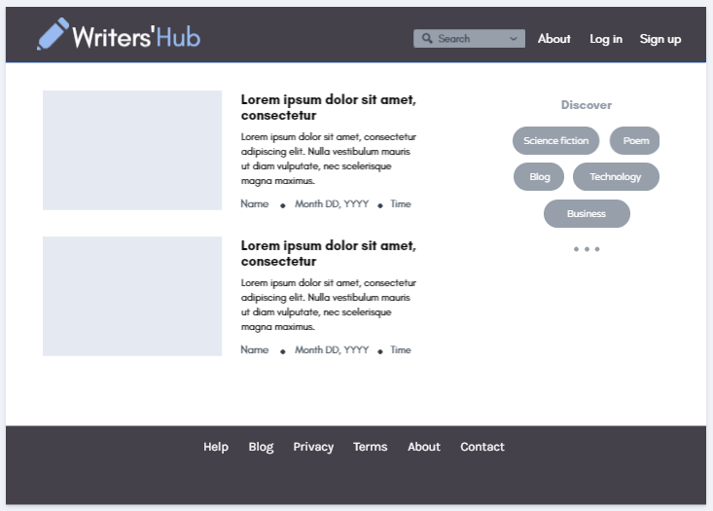

**Article Page:**

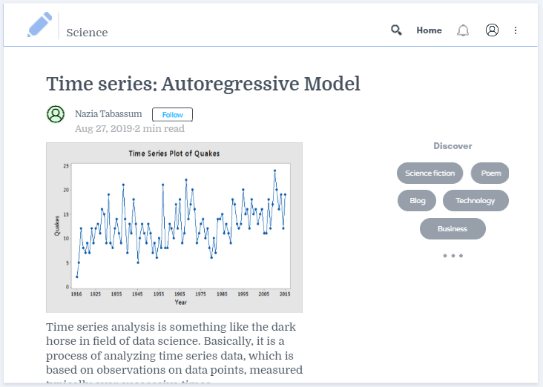

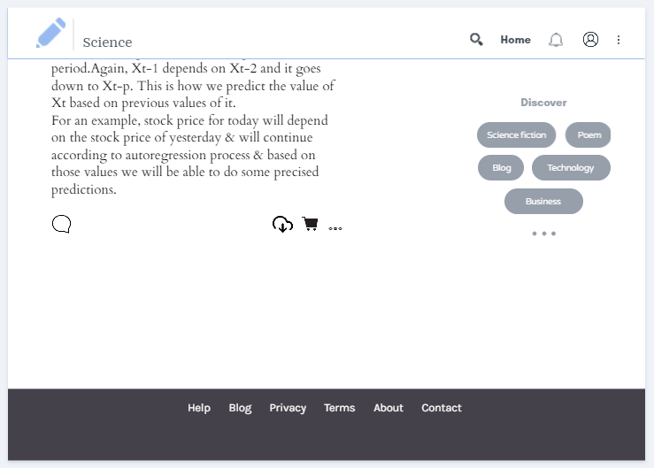

**Admin Dashboard:**

